

**A Minor Project Report on**

**ULTRASONIC GLASSES FOR BLIND PEOPLE USING ARDUINO**

**Submitted by**

BARATHKUMAR R (927621BEE013)

JANANI S (927621BEE051)

NAVEENA A (927621BEE306)



**DEPARTMENT OF ELECTRICAL AND ELECTRONICS ENGINEERING**

**M.KUMARASAMY COLLEGE OF ENGINEERING**

(An Autonomous Institution Affiliated to Anna University, Chennai) THALAVAPALAYAM, KARUR-639113.

DECEMBER 2022

## M.KUMARASAMY COLLEGE Of ENGINEERING

(Autonomous Institution, Affiliated to Anna University, Chennai)

## BONAFIDE CERTIFICATE

Certified that this Report titled **“ULTRASONIC GLASSES FOR BLIND PEOPLE USING ARDUINO”** is the bonafide work of **BARATHKUMAR R (927621BEE013), JANANI S (927621BEE051), NAVEENA A (927621BEE306)** who carried out the work during the academic year (2022-2023) under my supervision. Certified further that to the best of my knowledge the work reported herein does not form part of any other project report.

## SUPERVISOR HEAD OF THE DEPARTMENT

Mrs.P.SASIREKHA M.E., Dr.C.KUMAR M.E., Ph.D.,

Assistant Professor Professor & Head

Department of Electrical and

Electronics Engineering Department of Electrical and Electronics Engineering

M.Kumarasamy College of M.Kumarasamy College of Engineering, Karur Engineering, Karur

Submitted for Minor Project I (18EEP201L) viva-voce Examination held at M.Kumarasamy College of Engineering,Karur-639113 on ………………..

## DECLARATION

We affirm that the Minor Project report titled “**ULTRASONIC GLASSES FOR BLIND PEOPLE USING ARDUINO**” being submitted in partial fulfillment for the award of **Bachelor of Engineering in Electrical and Electronics Engineering** is the original work carried out by us.

|  |  |  |
| --- | --- | --- |
| **REG.NO** | **STUDENT NAME** | **SIGNATURE** |
| **927621BEE013** | **BARATH KUMAR R** | **------------------------** |
| **927621BEE051** | **JANANI S** | **------------------------** |
| **927621BEE306** | **NAVEENA A** | **------------------------** |

## VISION AND MISSION OF THE INSTITUTION

**VISION**

* To emerge as a leader among the top institutions in the field of technical education

## MISSION

* Produce smart technocrats with empirical knowledge who can surmount the global Challenges.
* Create a diverse, fully-engaged, learner - centric campus environment to provide Quality education to the students.
* Maintain mutually beneficial partnerships with our alumni, industry and Professional associations.

**DEPARTMENT OF ELECTRICAL AND ELECTRONICS ENGINEERING**

**VISION**

To produce smart and dynamic professionals with profound theoretical and practical knowledge comparable with the best in the field.

## MISSION

* Produce hi-tech professionals in the field of Electrical and Electronics Engineering by inculcating core knowledge.
* Produce highly competent professionals with thrust on research.
* Provide personalized training to the students for enriching their skills.

## PROGRAMME EDUCATIONAL OBJECTIVES(PEOs)

* **PEO1:** Graduates will have flourishing career in the core areas of Electrical Engineering and also allied disciplines.
* **PEO2:** Graduates will pursue higher studies and succeed in academic/research careers
* **PEO3:** Graduates will be a successful entrepreneur in creating jobs related to Electrical and Electronics Engineering /allied disciplines.
* **PEO4:** Graduates will practice ethics and have habit of continuous learning for their success in the chosen career.

## PROGRAMME OUTCOMES(POs)

After the successful completion of the B.E. Electrical and Electronics Engineering degree program, the students will be able to:

**PO1: Engineering Knowledge:** Apply the knowledge of mathematics, science, engineering fundamentals, and an engineering specialization to the solution of complex engineering problems.

**PO2: Problem Analysis:** Identify, formulate, review research literature, and analyze complex engineering problems reaching substantiated conclusions using first principles of mathematics, natural sciences, and engineering sciences.

**PO3: Design/Development of solutions:**

Design solutions for Complex engineering problems and design system components or processes that meet the specified needs with appropriate consideration for the public health and safety, and the cultural, societal and environmental considerations.

**PO4: Conduct Investigations of complex problems:** Use research-based knowledge and research methods including design of experiments, analysis and interpretation of data, and synthesis of the information to provide valid conclusions.

**PO5: Modern Tool Usage:** Create, select, and apply appropriate techniques, resources, and modern engineering and IT tools including prediction and modeling to complex engineering activities with an understanding of the limitations.

**PO6: The Engineer and Society:** Apply reasoning in formed by the contextual knowledge to assess societal, health, safety, legal and cultural issues and the consequent responsibilities relevant to the professional engineering practice.

**PO7: Environment and Sustainability:** Understand the impact of the professional engineering solutions in societal and environmental contexts, and demonstrate the knowledge of, and need for sustainable development.

**PO8: Ethics:** Apply ethical principles and commit to professional ethics and responsibilities and norms of the engineering practice.

**PO9: Individual and Team work:** Function effectively as an individual, and as a member or leader in diverse teams, and in multi-disciplinary settings.

**PO10: Communication:** Communicate effectively on complex engineering activities with the engineering community and with society at large, such as, being able to comprehend and write effective reports and design documentation, make effective presentations, and give and receive clear instructions.

**PO11: Project Management and Finance:** Demonstrate knowledge and understanding of the engineering and management principles and apply these to one’s own work, as a member and leader in a team, to manage projects and in multi-disciplinary environments.

**PO12: Life-long learning:** Recognize the need for, and have the preparation and ability to engage in independent and life-long learning in the broadest context of technological change.

**PROGRAM SPECIFIC OUTCOMES(PSOs)**

The following are the Program Specific Outcomes of Engineering Students:

* **PSO1:** Apply the basic concepts of mathematics and science to analyze and design circuits, controls, Electrical machines and drives to solve complex problems.
* **PSO2:** Apply relevant models, resources and emerging tools and techniques to provide solutions to power and energy related issues & challenges.
* **PSO3:** Design, Develop and implement methods and concepts to facilitate solutions for electrical and electronics engineering related real world problems.

|  |  |
| --- | --- |
| **Abstract (Key Words)** | **Mapping of POs and PSOs** |
| **Arduino Board, Ultrasonic Sensors,**  **Laser Module, Speaker, Connecting Wires.** | PO1, PO2, PO3, PO4, PO5, PO6, PO7, PO8 PO9, PO10, PO11, PO12, PSO1,PSO2,PSO3. |

[**ACKNOWLEDGEMENT**](https://www.google.com/search?rlz=1C1CHBD_enIN820IN820&q=ACKNOWLEDGEMENT&spell=1&sa=X&ved=0ahUKEwj99az1_ZXhAhVN63MBHRVODE4QkeECCCkoAA&cshid=1553265789884876)

Our sincere thanks to **Thiru.M.Kumarasamy, Chairman and Dr.K.Ramakrishnan,B.E, Secretary** of **M.Kumarasamy College of Engineering** for providing extra ordinary infrastructure, which helped us to complete the Minor project in time.

It is a great privilege for us to express our gratitude to our esteemed **Principal Dr.N.Ramesh Babu M.E, Ph.D,** for providing us right ambiance for carrying out the project work.

We would like to thank our **Head of the Department Dr.C.Kumar M.E, Ph.D, Department of Electrical and Electronics Engineering,** for their unwavering moral support throughout the evolution of the project.

We would like to express my deep gratitude to our Minor Project Guide **Mrs.P.Sasirekha ME, Assistant Professor, Department of Electrical and Electronics Engineering,** for her constant encouragement, kind co-operation, valuable suggestions and support rendered in making our project a success.

We offer our whole hearted thanks to our Minor project coordinator

**Dr.S.Jaisiva ME., Ph.D. Assistant Professor, Department of Electrical and Electronics Engineering,** for his constant encouragement, kind co-operation and valuable suggestions for making our project a success.

We glad to thank all the **Faculty Members** of **Department of Electrical and Electronics Engineering** for extending a warm helping hand and valuable suggestions throughout the project.

Words are boundless to thank **Our Parents and Friends** for their constant encouragement to complete this Minor project successfully.

**TABLE OF CONTENTS**

|  |  |  |
| --- | --- | --- |
| **CHAPTER NO** | **TITLE** | **PAGE NO** |
|  | **ABSTRACT** | 2 |
|  |  |  |
| **1** | **INTRODUCTION** | 3 |
|  | 1.1 Introduction | 3 |
|  | 1.2 Scope of the work | 3 |
| **2** | **SYSTEM MODEL** | 4 |
|  | 2.1 Introduction | 4 |
|  | 2.2 Block Diagram | 4 |
|  | 2.3 Description of Various blocks | 4 |
| **3** | **HARDWARE DESCRIPTION** | 5 |
|  | 3.1 Introduction | 5 |
|  | 3.2 Circuit diagram | 5 |
|  | 3.3 Description of Components | 5 |
| **4** | **RESULT AND DISCUSSION** | 8 |
|  | 4.1 Hardware Implementation | 8 |
|  | 4.2 Working of Project model | 8 |
|  | 4.3 Result | 9 |
| **5** | **CONCLUSION AND FUTURE SCOPE** | 10 |
|  | 5.1 Conclusion | 10 |
|  | 5.2 Applications | 10 |
| **6** | **REFERENCES** | 11 |

**LIST OF TABLE**

|  |  |  |
| --- | --- | --- |
| **TABLE NO** | **TITLE** | **PAGE NO** |
| 3.1 | Hardware components and its cost | 5 |

**LIST OF FIGURES**

|  |  |  |
| --- | --- | --- |
| **FIG.NO** | **TITLE** | **PAGE NO** |
| 2.1 | Block diagram of the system | 4 |
| 3.1 | Circuit diagram of the system | 5 |
| 3.2 | Arduino | 6 |
| 3.3 | Ultrasonic Sensor | 6 |
| 3.4 | Speaker | 7 |
| 3.5 | Laser Module | 7 |
| 4.1 | Experimental setup | 8 |

**ABSTRACT**

These “Smart Glasses” are designed to help the blind people. It is used to walk for helping them navigate the ground. To make a prototype of glasses which can be able to detect the objects in front of them, and tell the user by speaking. This smart glasses can make a huge impact in the lives of blind people. These Ultrasonic Smart Glasses for Blind people is a portable device, easy to use, light weight, user friendly and cheap in price. These glasses could easily guide the blind people and help them avoid obstacles.

**CHAPTER 1**

**INTRODUCTION**

* 1. **INTRODUCTION**

There are multiple smart accessories such as smart glasses, smartwatches, etc. Available in the market. But all of them are built for us. There is a significant lack of technology to aid the physically challenged. I wanted to build something that is useful for visually challenged people. So I designed low-cost smart glass that can be used to help the visually impaired. The circuit board used in this project is designed in the form of a spectacle, which can be worn by a visually impaired person.

* 1. **SCOPE OF WORK**

There are multiple smart accessories such as smart glasses, smartwatches, etc. Available in the market. But all of them are built for us. There is a significant lack of technology to aid the physically challenged. I wanted to build something that is useful for visually challenged people. So I designed low-cost smart glass that can be used to help the visually impaired. The circuit board used in this project is designed in the form of a spectacle, which can be worn by a visually impaired person. By using this product, they will become independent and will not depend on any one else for their daily life activity which they required to depend on all time.

**CHAPTER 2**

**SYSTEM MODULE**

**2.1 Introduction**

The level of gas is can’t be known in LPG cylinder, so that we can’t pre-book for LPG cylinder. And the other problem facing with this LYG cylinder is gas leakage.

**2.2 Block diagram**

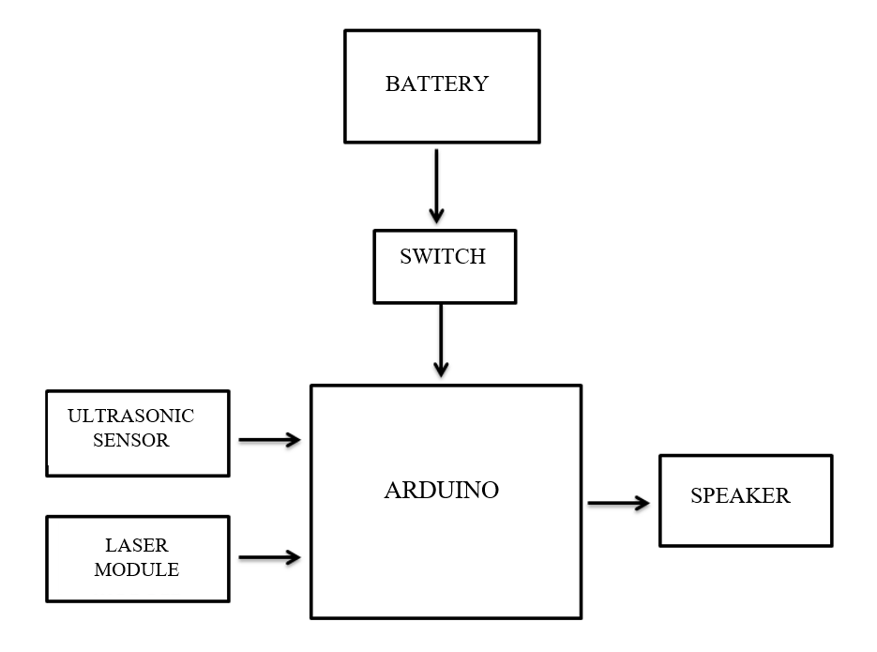

**Figure 2.1 Block Diagram**

Power supply

Mobile phone

Wi-Fi module

**2.3 Description of Various blocks**

The 9V Battery Supplies Power to the Hardware which is connected to the Arduino. The Arduino has Programmed which gives Output. The Laser Module and Ultrasonic Sensors gets the Input. Then the Output is Produced by the Speaker.

**CHAPTER 3**

**HARDWARE DESCRIPTION**

**3.1 Introduction**

The Principal objects are Ultrasonic Sensor and Laser Module. The Arduino gets the input and produces the Output. The Arduino measures the Distance and produces the Output.

**3.2 Circuit Diagram**

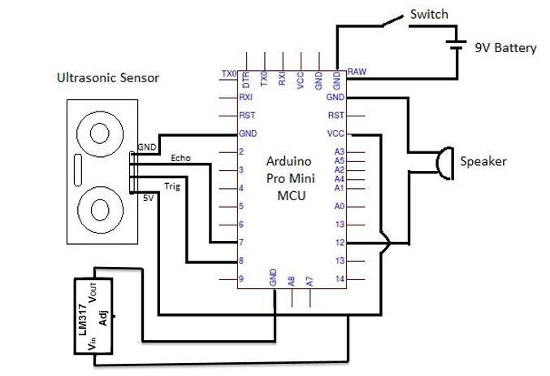

**Figure 3.1 Hardware Circuit Diagram**

**3.3 Description of Components**

|  |  |  |
| --- | --- | --- |
| **S.No** | **Name of the Components** | **Specification** |
| 01 | Arduino | UNO R3 SMD |
| 02 | Ultrasonic Sensor | HC-SR04 (upto 4 meter) |
| 03 | Laser Module | 650 nm |
| 04 | Speaker | - |
| 05 | Battery | 9V |

**3.3.1 ARDUINO UNO:**

Arduino UNO is open-source microcontroller board based on the AT mega 328P.We can directly connect the board to the computer via a USB cable which performs a function of supplying the power as well as acting as a serial port.

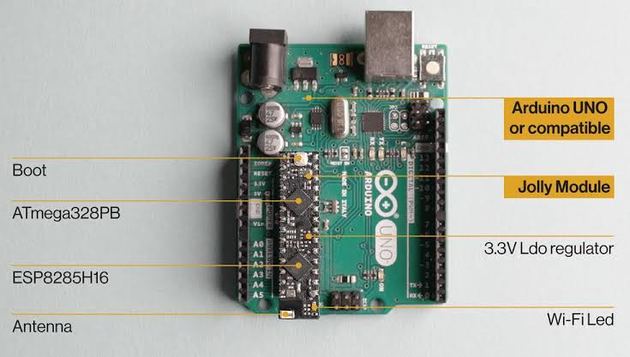

**Figure 3.2 Arduino**

**3.3.2 ULTRASONIC SENSORS:**

The purpose of ultrasonic sensors is to measure the distance using ultrasonic waves. Ultrasonic sensors emit the ultrasonic waves and receive back the reflected. So, by this time the ultrasonic sensor will measure the distance to the object. It can sense from 2-400 cm. The distance should be from 40 cm to 150 cm and that is because this is the required ranging capture a clear image.

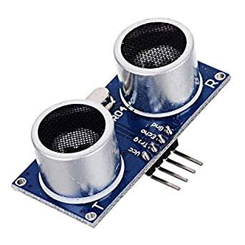

**Figure 3.3 Ultrasonic Sensor**

**3.3.3 SPEAKERS:**

A Speaker is one type of electroacoustic transducer that is a device that converts an electrical audio signal into corresponding sound. An audio signal is amplified electrically to the power level capable.

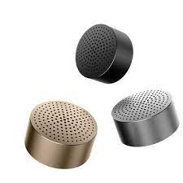

**Figure 3.4 Speakers**

**3.3.4 LASER MODULE:**

The laser beam signal is used in this system a circuit is designed which will detect this laser beam and will calculate the intensity of the signal and distance. A TOF(time-of-flight) laser range finder consists of a laser transmitter, one or two receivers and timing discriminators, and a time measuring unit. In the transmitter usually avalanche transistors are used for generating the short (3–10 ns) and powerful (20–100 A) current pulses for the semiconductor laser

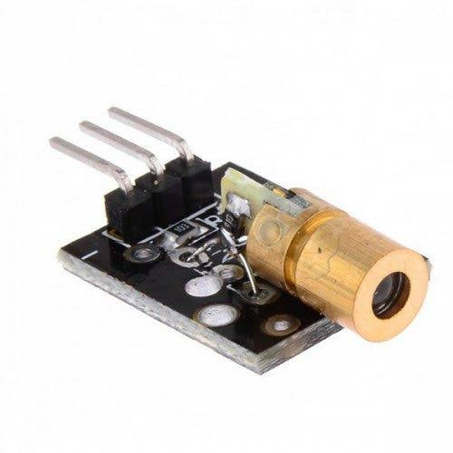

**Figure 3.5 Laser Module**

**CHAPTER 4**

**RESULT AND DISCUSSION**

**4.1 Hardware Implementation**

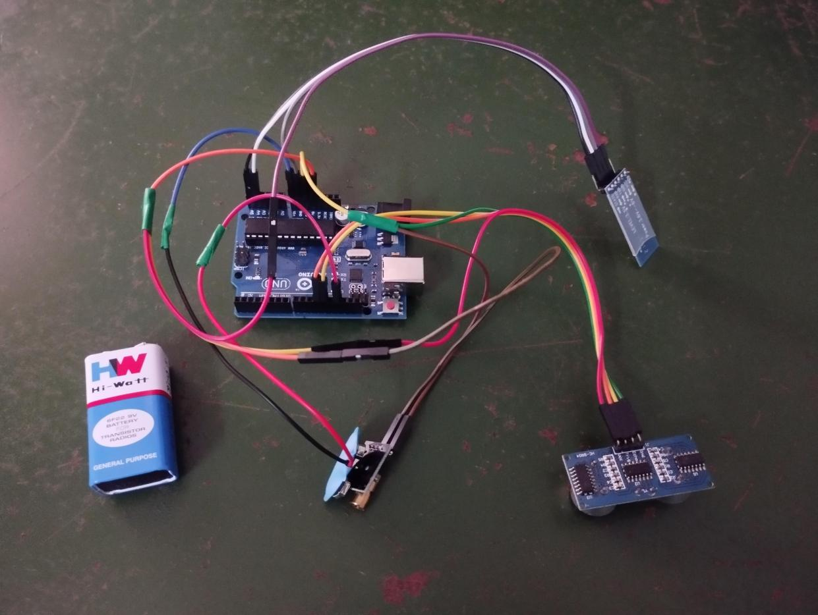

**Figure 4.1 Project Hardware**

* 1. **Working of Project Model**

First The Switch is turned on then the power supply is given to the circuit. Next the power given to the Arduino then the Arduino takes input from the Ultrasonic Sensor and Laser Module (This are used to measure the distance). The Ultrasonic Sensor and Laser Module given input to the Arduino then its takes 5secs for complete analysis of the distance and fix the distance. After than User moving to the target location between that if there is a distractions like obstacles and pits it will detect and communicate to the User. If there is an obstacle then the distance will reduce then it finds there is an obstacle. If there is a pit then the distance will increase then it finds there is an pits. This input is given to the Arduino then produce Output in the Speaker and helps the User to reach the target location.

* 1. **Result**

The Gadget is used to measure the distance to get input and the Arduino gives the output signal to the Speaker which is the Audio output. The Audio output to the Visually Challenged people is if the distance is low it takes as the obstacle then it gives output as an “There is an Obstacles” and then tells which direction to move and if the distance is high it takes as there is an pits then it gives output as an “There is an Hole” and then tells which direction to move. This the Audio output which is easily understandable to the Visually Challenged People.

**CHAPTER 5**

**CONCLUSION AND FUTURE SCOPE**

**5.1 CONCLUSION**

This smart glass implemented for blind person who are unable to see any object so this person can aware about accident. In future it can be implemented as a image recognization where sensor give information user about the object.

* 1. **APPLICATION**

Their small size makes it easy to integrate into projects. Ultrasonics can easily integrate with any type of controller. Their high frequency, sensitivity, and power make it easy to detect objects. They have greater accuracy than many other methods at measuring thickness and depth of a parallel surface. Ultrasonics are easy to use and not dangerous during operation

**REFERENCE**

* [1] Feng Lan, Guangtao Zhai and Wei Lin, "Lightweight smart glass system with audio aid for visually impaired people", TENCON IEEE Region 10 Conference*,* 2015.
* [2] ASM Iftekhar Anam, Sahinur Alam and Md Yeasin, "A dyadic conversation aid using google glass for people who are blind or visually impaired", Mobile Computing Applications and Services (MobiCASE)6th International Conference, 2015.
* [3] Tailong Shi, Bruce and Ting-Chia Huang, "Design Demonstration and characterization of Ultra-Thin Low-Warpage Glass BGA Packages for smart mobile Application processor", Electronics Components and Technology Conference (ECTC) 2016 IEEE 66th, 2016.
* [4] W.C.S.S. Simoes and V.F. de Lucena, "Blind user wearable audio assistance for indoor navigation based on visual markers and ultrasonic obstacle detection", Consumer Electronics (ICCE) 2016 IEEE International Conference*,* 2016.
* [5] Hsieh Chishenng, "Electronic talking stick for blind", US5097856A, March 1992.
* [6] Humberto Orozco Cervantes, “Intelligent glasses for he visually impaired”, US20150227778Al, Aug 2015.
* [7] S. Pinto, T. Castro and N. Brito, "ClimaWin: An intelligent window for optimal ventilation and minimum thermal loss", Industrial Electronics (ISIE) 2013 IEEE International Symposium, 2013.
* [8] Md Sheikh Sadi, Saifudin Mahmud, Md Mostafa Kamal and Abu Ibne Bayazid, "Automated walk-in assistant for blinds", Electrical Engineering and Information and Communication Technology (ICEEICT) 2014 International Conference*,* 2014.
* [9] Dariush Forouher, Marvin Grobe Besselmann and Erik Maehle, "Sensor Fusion Of Depth camera and ultrasound data for obstacle detection and robot navigation*",*Control Automation Robotics and vision (ICARCV) 2016 14th Internatonal Conference, 2016.
* [10] T.O. Hoydal and J.A. Zelano, "An alternative mobility aid for the blind: the ultrasonic cane", Bioengineering Conference Proceedings of the 1991 IEEE Seventeenth Annual NorthEast*,* 1991.
* [11] "An intelligent auxiliary system blind glasses” CNI06937909A", Chinese Author, July 2017.